Acceptance Letter

Paper Title: Deep Learning Models for Non-Invasive Blood Group Detection Using Fingerprint Images
Acceptance/Paper ID: ICIMA-376
Authors: Rajendra Prasad Banavathu, Yaswanth Kumar Peddagamalla, Sai Tripurambika Reddy Kolli, Holi Sree Navya Nakka, Yadavalli Sunny

On behalf of the Technical Program Committee of the 8th International Conference on Inventive Material Science and Applications (ICIMA 2026), we are pleased to inform you that your manuscript has been accepted for presentation and inclusion in the conference proceedings, subject to satisfactory completion of the final submission requirements. The ICIMA 2026 Conference will be held from 13–15 May 2026 at Muthayammal Engineering College, Namakkal, India.
You are hereby invited to submit the camera-ready version of your paper for inclusion in the official ICIMA 2026 Proceedings. Ensure that the revised manuscript strictly adheres to the prescribed formatting and publication guidelines. Timely submission of the camera-ready manuscript and completion of all mandatory formalities are essential to ensure successful publication. Please note that acceptance is contingent upon compliance with IEEE publication standards and successful completion of the registration and copyright procedures.
We congratulate you on the acceptance of your paper and look forward to your valuable contribution and presentation at ICIMA 2026.

Yours sincerely,


Organizing Chair 8th ICIMA 2026

Technical comments
Review comments:

- Kindly update the training parameters like optimizer, learning rate, batch size and number of epochs in the methodology section
- It is suggested to include the total number of images per blood group class to better understand class imbalance
- The confusion matrix analysis (Figure 3) should include numerical misclassification counts for each class
- Kindly report training time, GPU type and inference time per fingerprint image properly
- It is suggested to compare the proposed models with earlier MobileNetV2 and ResNet50 results under the same dataset
- Kindly remove the IEEE text from the specified template to ensure that the manuscript complies with the required format. Some minor English elements are missing from the manuscript. Kindly review and address these omissions to improve its completeness.

- Kindly update the training parameters like optimizer, learning rate, batch size and number of epochs in the methodology section
A:
All the backbone models were trained with the same set of hyperparameters. The optimizer, learning rate, batch size, and number of epochs were set to be the same for all experiments. Mixed precision training was also enabled to reduce the computational cost of training on the GPU.
Training Configuration
Parameter | Value
Optimizer | AdamW
Initial Learning Rate | 1 × 10⁻⁴
Weight Decay | 1 × 10⁻⁴
Batch Size | 32
Number of Epochs | 25
Loss Function | Cross-Entropy Loss
Precision Mode | Mixed Precision (AMP)
Scheduler | ReduceLROnPlateau
All models were trained on the same training dataset, and validation data was used to monitor performance and adjust learning rate when necessary.
- It is suggested to include the total number of images per blood group class to better understand class imbalance
A:
The data is split into training, validation, and test sets. A stratified splitting method was used to maintain the same ratio for all subsets. This method promotes an unbiased evaluation and helps to avoid the effects of imbalance on the performance of classes.
Dataset Split Distribution
Blood Group | Training | Validation | Test | Total
A+ | 954 | 205 | 204 | 1363
A− | 1679 | 360 | 359 | 2398
AB+ | 1185 | 254 | 254 | 1693
AB− | 1281 | 274 | 275 | 1830
B+ | 1088 | 233 | 233 | 1554
B− | 1266 | 271 | 272 | 1809
O+ | 1410 | 302 | 303 | 2015
O− | 1192 | 256 | 255 | 1703
Total | 10055 | 2155 | 2155 | 14365

- The confusion matrix analysis (Figure 3) should include numerical misclassification counts for each class
A:
The confusion matrix provides a clear display of the actual number of classification predictions for each of the eight blood types. It is evident that there is a strong diagonal dominance, which indicates that there is a high level of correct predictions for each class. For example, there were a high number of correct predictions for each class, and the number of incorrect predictions was low and mostly between the similar blood types. These numbers form the basis of the robustness and high discriminative power of the proposed EfficientNetV2-S model.
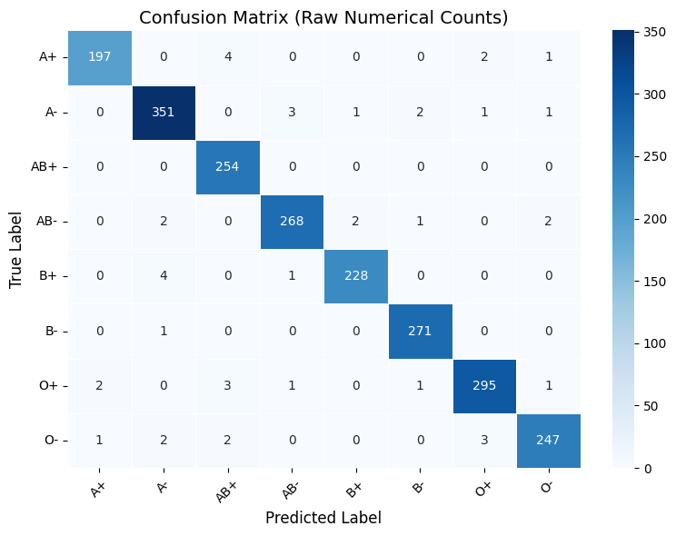
Confusion matrix of EfficientNetV2-S for eight blood group classes

4. Kindly report training time, GPU type and inference time per fingerprint image properly
A:
For the assessment of the feasibility of the proposed system, the computational power of the system has been analyzed in terms of training speed and inference time. For all experiments, the GPU environment has been used to ensure equal hardware settings. The training time has been measured for all epochs, and the inference time has been measured per fingerprint image with a batch size of one. The results give an indication of the real-time feasibility of the proposed system.
Hardware and Computational Performance
Parameter | Value
Hardware Platform | Google Colab (Google Compute Engine)
GPU Type | NVIDIA Tesla T4
GPU Memory | ~15 GB VRAM
Total Training Time | 31.5 seconds (0.53 minutes)
Average Time per Epoch | 1.26 seconds
Number of Epochs | 25
Average Inference Time | 35.91 ms
Throughput | 27.84 images/second
Test Samples | 2,155
- It is suggested to compare the proposed models with earlier MobileNetV2 and ResNet50 results under the same dataset
A:
Comparison with Baseline CNN Models under Same Dataset
Model | Test Accuracy (%)
ResNet50 | 97.12
MobileNetV2 | 97.91
EfficientNetV2-S (Proposed) | 98.84
To improve the understanding and proof of the effectiveness of the proposed framework, a set of additional experiments was performed using two established baseline models: ResNet50 and MobileNetV2. The additional experiments strictly followed the same data split, data preprocessing steps, and training settings used in the previous set of experiments. As shown in Table 5, EfficientNetV2-S reported the highest accuracy of 98.84%, outperforming ResNet50 (97.12%) and MobileNetV2 (97.91%). Taken together, these findings confirm the strong generalization performance of the proposed backbone network in the unified fingerprint-based blood group detection system.

